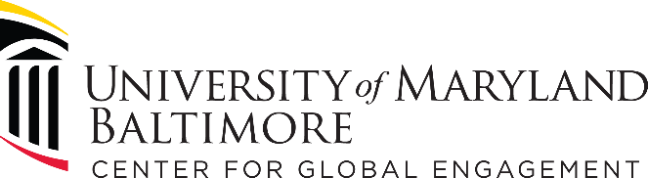

Developing Faculty-Led Student Programs at UMB

Program Leadership

- Name of lead faculty member and title.
- Lead UMB school (and department if applicable).
- Other faculty members on U.S. side and titles.
- Name of lead international collaborator(s), organization, and title.

Academic and Curricular Considerations
- Is this a new course? If so, what is the course title and provide a short description.
- If this is a course, will the course be for credit? Is it open to students outside the lead school?
- Is this a research experience? If so, provide a brief description of the research.
- If research is required, will IRB approval be required at UMB and/or in the international location?
- Is this an observational experience? If so, describe the experience and how it will benefit students.
- Is this a clinical experience?
- If a clinical experience, who will provide clinical supervision? Who will decide what clinical activities the students are allowed to engage in and what are regulations for clinical practice in that location?
- What are the desired learning outcomes for students?
- Explain how the program is bidirectional and mutually beneficial to UMB and the international partner.
- What kinds of interaction will students have with students and others at the international site?
- Does the program fulfill any requirement for any UMB program?
- Is this a stand-alone program or part of a UMB course?

Logistics
- Location of experience and local partner organization or university
- Describe the relationship between the course and the location
- Is the program traveling (multiple city/country) or stationary (one main city/country)?
- Approximate program dates
- Program duration (number of weeks)
- Types of transportation
- Type of housing (are meals included?)
- Will the students have free time for tourism?
- Minimum/maximum number of participants

Application and Participation
- Target student audience?
- Academic requirements to participate?
- Will there be an application process, will it include an interview?
- Are there non-academic requirements (language, skills, equipment, physical)
- Is the program open to all UMB students?
- Is the program open to non-UMB students?

