Vanderbilt/Meharry REDCap Mobile App Manual
Contents
REDCap Mobile App – what it is 3
REDCap Mobile App – why you would use it 3
Use Cases 3
REDCap Mobile App – what it isn’t 3
REDCap Online vs Offline Comparison 4
Supported Devices 5
Compatibility 5
Security 5
Definitions 5
Features 6
Mobile App Users 6
Admin Users 6
User Rights in Main REDCap Project 7
User Rights in Mobile App 7
RECOMMENDATIONS: 8
App Workflow 8
Getting Started 8
Procedure 8
Download the app 9
Using Mobile App 10
Data collection (OFFLINE – NO INTERNET CONNECTION) 12
Sending Data 13
Send Emergency Data Dump 16
Remote Lockout 16
Mobile App Activity Log 17
REDCap Mobile App in REDCap database, or online on a device (not in App) 17
Reporting a bug/problem 19
Translate the Mobile App Interface 19
Current interface translations 19
Action Tags 20
Best Practices 20
In-Depth Manual in the App 21
Frequently Asked Questions 22
MyCap 24
REDCap vs. MyCap comparison 24
Resources 24
Acknowledgements 25

REDCap Mobile App – what it is
The REDCap Mobile App is an application that gives your study team the capability to collect REDCap data in an offline (without internet) environment. They can then sync the data back to the REDCap project on the REDCap server when they have access to the internet.

REDCap Mobile App – why you would use it
You might use the REDCap Mobile app if you have a study that takes place in an area with unreliable internet connectivity. You would have data collectors (study team members) who are in the field, entering data on behalf of study participants.

Use Cases
To give you an idea of when it might be helpful to use the REDCap Mobile app, here are some real-life examples of how it has been used by Vanderbilt/Meharry users as well as users from other institutions with REDCap:
- Rural/remote settings
  - Breast-feeding project in rural Guatemala
  - Mobile skin cancer project in Brazil
  - Data collection in refugee settlement in Uganda
  - Population health studies
- Home care surveys
- Health fairs

REDCap Mobile App – what it isn’t
The REDCap Mobile App is not an app that you would add to your smart phone to access your REDCap projects. When designing your project and viewing data, you would use the online version of REDCap.
The REDCap Mobile app is not an app that a study participant downloads on their phone. If you want study participants to provide information themselves, you might consider MyCap.
The REDCap Mobile app is not a survey tool. This means that it will not support survey features.

REDCap Online vs Offline Comparison
You DO NOT need to use the Mobile App to enter data into REDCap from a device. If you have an internet connection, you can simply use a browser to collect data through surveys or data entry forms.
Below is a comparison of the two options:
REDCap Online | Mobile App
Web-based application | Native Application
Runs in browser | Runs on iOS and Android devices
Needs and internet connection to work properly | Does not require an internet connection
Use if there is a reliable and secure and internet connection | Use if there is no, or an unreliable, internet connection
Data is directly entered into the REDCap project once a form is saved on the device. No data is stored on the device. | Data is saved on the device once a form is saved, and will not be entered in the main REDCap project until data is synced (via an internet connection).
Data is always up-to-date in the REDCap project. | Data might be out of sync if the data stored on the device is not regularly synced to the main REDCap project.
No additional security measures required on the device. | Further security measures must be taken to ensure data security.
The REDCap interface is exactly the same as it is on desktop. | The interface is adjusted to fit uniquely for a mobile device, and looks slightly different.
User accounts and rights set in REDCap are applicable. | Separate user accounts and user rights are needed to be created in the App and API tokens are required to link back to user accounts in the main REDCap project.

Supported Devices
- Android and iOS devices only.
  - Android minimum operating system required: version 4.3 or later
  - iOS minimum operating system required: 9.0 and later
- Amazon Fire devices not supported

Compatibility
- iOS - Works on iPhone 4 and up, iPad 2 and up - requires iOS 9.0 or later
- Android - Requires Android 4.3 and up
- Device must support Encryption.
- Currently, the app does not support complex REDCap project structure (Large number of events / Fields/Instruments).

Security
For detailed information about what security standards are applied in the app, please see this document: https://projectredcap.org/wp-content/resources/security.pdf

Definitions
- Principal Investigator (PI): Primary individual in charge of and responsible for the proper conduct of a research project and/or sponsor for non-research projects.

- Project Administrator (PA): Person responsible for the development of REDCap data instruments and the overall management of the project data.

- Research Team/Project Team: Research/project assistants, nurses, data entry and other personnel involved with and granted access to the REDCap project. The Team Members report to the PI but are generally directly supervised by the PA.

- REDCap Team: Vanderbilt/Meharry Support Team that is responsible for supporting REDCap end users.

- REDCap API (Application Programming Interface): Interface that allows external applications to connect to REDCap remotely, and is used for programmatically retrieving or modifying data or settings within REDCap, such as performing automated data imports/exports to/from a specified REDCap project.

- REDCap API Token: The Mobile App uses API tokens, which determine which data in REDCap are accessible from the app. These tokens consist of a 32-character hex string that is unique to a particular REDCap user’s rights in a particular REDCap project. Any given token can only be used to access a single project with the User Rights assigned to a particular REDCap user.

Features
The REDCap Mobile App supports the following features:
- The user interface allows multiple individuals to access the App on a single device via a secure login.
- Teams with multiple mobile devices have the capability to collect data for one project, or multiple projects simultaneously.
- Administrative functions and other participants’ records can be made secure prior to handing the mobile device to a data collector.
- In addition to text, photos can be captured by the mobile App and transmitted to the server.

Mobile App Users

Admin Users
The REDCap Mobile App uses an Admin account to manage its users. The Admin can create/update/delete Mobile App users, reset passwords and grant user rights on the App for specific projects. Project setup can be done by admin and regular App user accounts. In the REDCap Mobile App each user adds projects to their account through an API token. Each App user maintains unique project copies on the device and cannot share the same REDCap Mobile App projects. If multiple users need to access the same project, they each need to set-up the project independently under their account.
RECOMMENDATIONS:
- The REDCap App Admin account should be held by the REDCap Project Administrator (PA).
- Each App user must request an API token from REDCap Mobile App page through their main REDCap project account and set-up the project on the App using their user-specific QR or initialization Code.
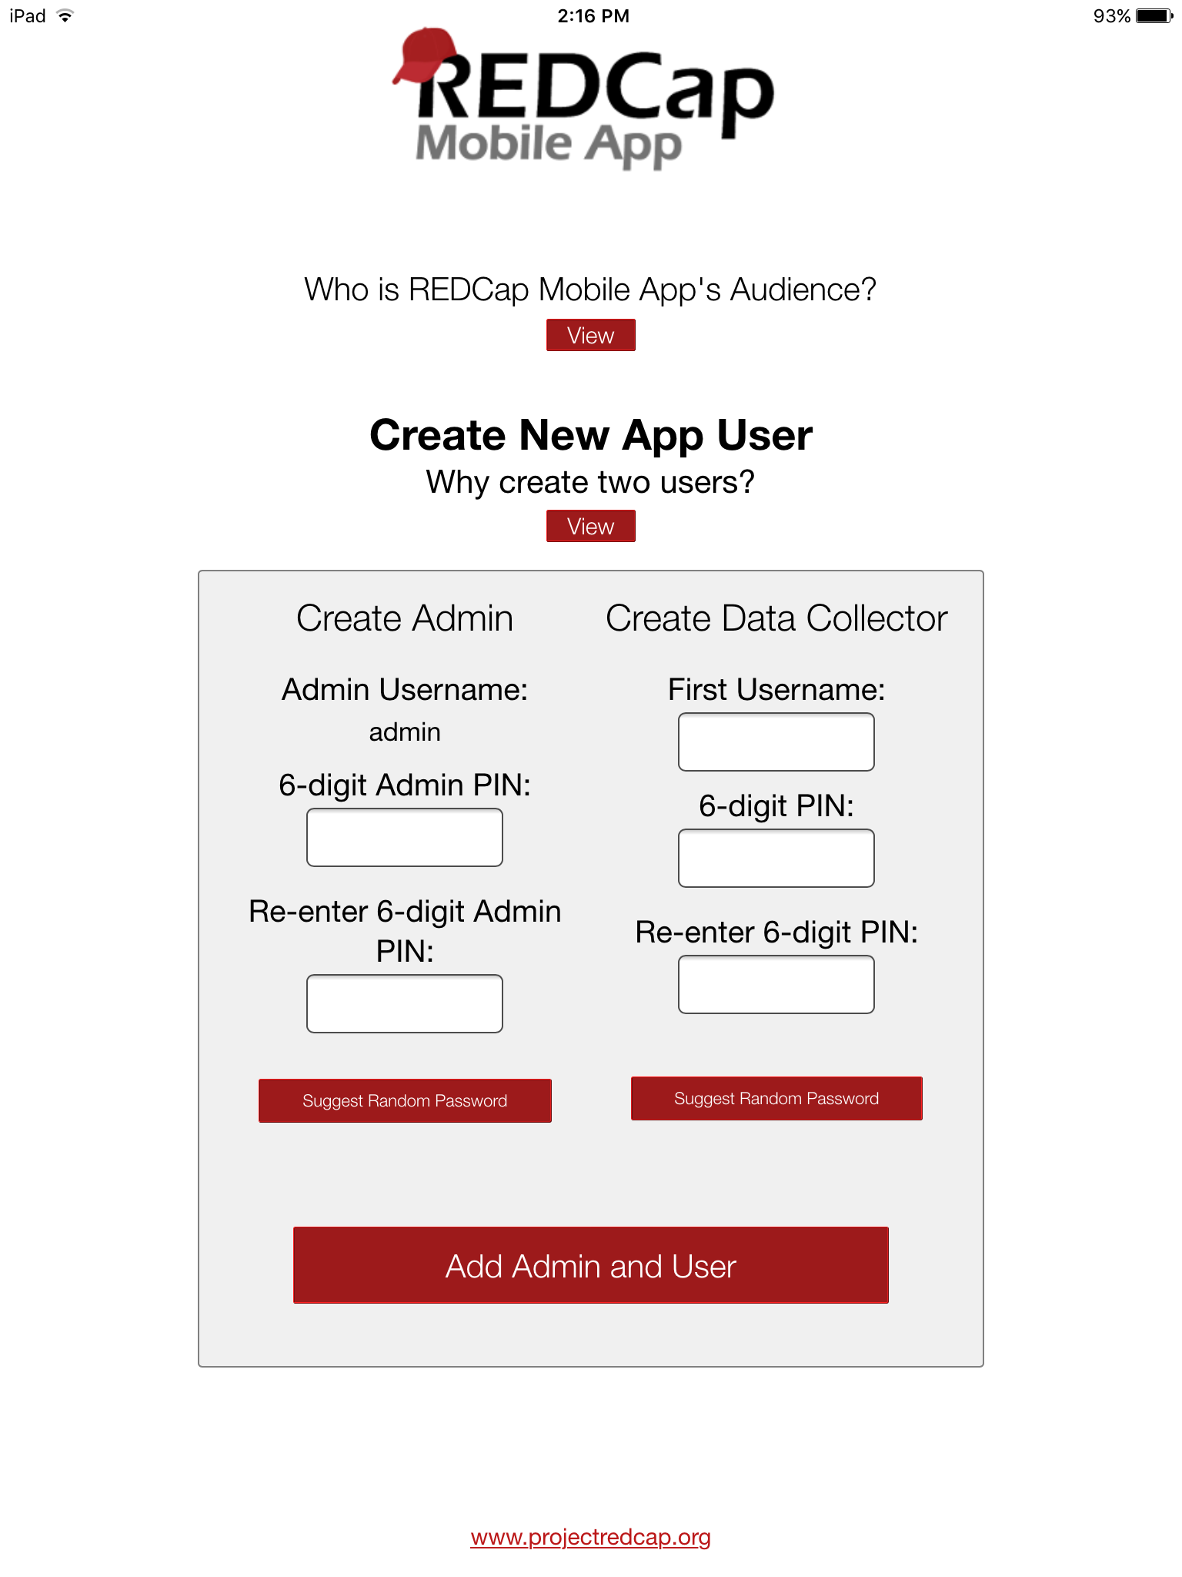
- Note: The Admin password cannot be reset, so don’t lose it!

User Rights in Main REDCap Project
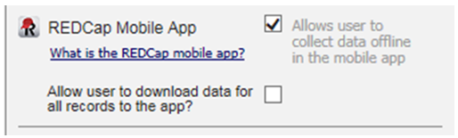

- The “REDCap Mobile App” privilege allows users to:
- Set up the project inside the Mobile App on your device.
- Collect data which is stored locally on the device.
- Sync that data back to this project on the REDCap server.
- The REDCap Mobile App section is where users can view the App log and file archive.

- The "Allow user to download data for all records to the app?” privilege allows users to:
- Download records from the server to the app.
- Unchecking this privilege prevents users from unwittingly (or wittingly) downloading lots of sensitive data to their mobile device.
- If a user is given this privilege, then when they initialize the project in the App and the project contains at least one record, then the App will prompt the user to choose if they wish to download all the records to the App or not.

User Rights in Mobile App
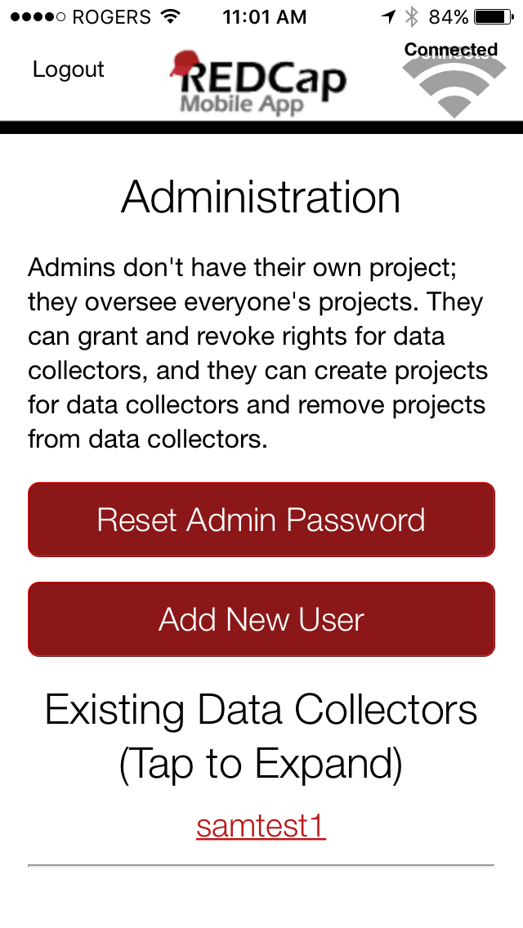
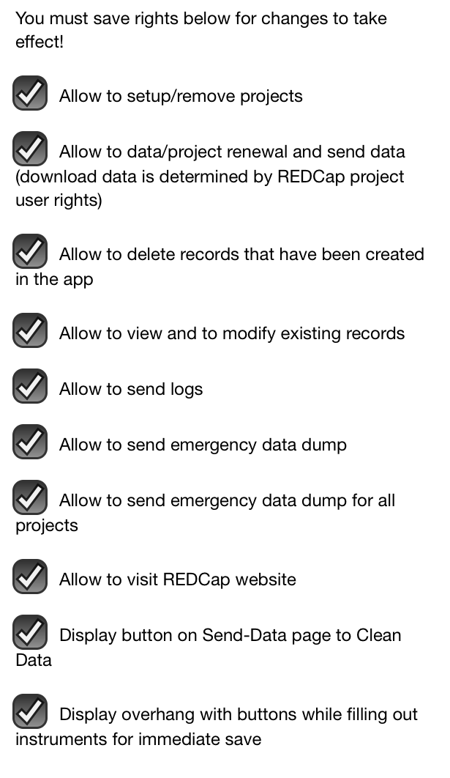
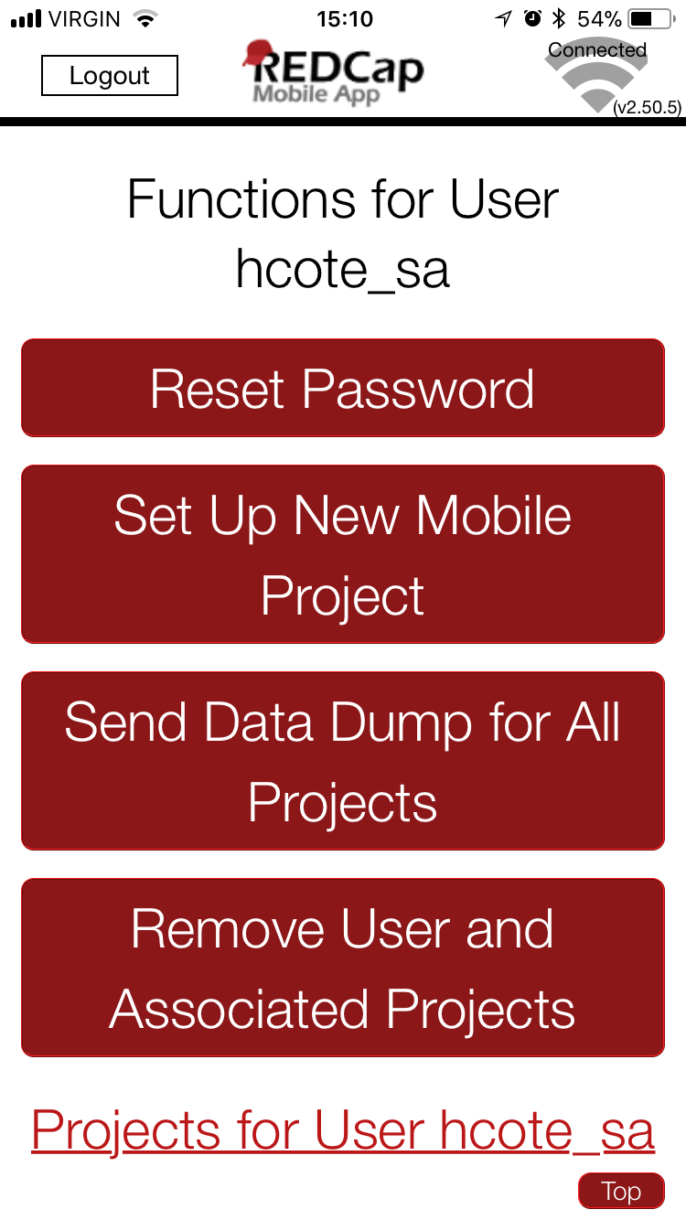

- Each user account must be created in the REDCap Mobile App and have specific rights assigned to it, which are separate from their main REDCap project user account.
- Users will have a different username and pin/password in the Mobile App compared to the main REDCap project.
- The main project user account is linked through their API token and will ensure the user privileges inside the App mimic the privileges in the main REDCap project, including form rights (no access, read only and edit) and Data Access Groups.
- If a user is on multiple app projects, the user rights set in the app apply to the whole user account, and are not project specific. All user rights on an app accounts will apply across all projects.

RECOMMENDATIONS:
 | REDCap Main Project | REDCap Mobile App
Project  Administrator | - Fill out REDCap Mobile App Request  - Designate Mobile App-specific user’s rights  - Assign REDCap Mobile App rights to PA in the server project | - Create own Admin account with pin (Admin pin CANNOT be reset)  - Create user accounts, require username and 6 digit pin  - Designate user's rights  - Can set up projects for users
Data Entry/  Regular User | - Acquire API token (QR code)  - Data Entry form rights and Data Access Groups are identical to the App | - Set-up project using QR or initialization Code  - Collect data  - Send data to the server and clean and reset project as soon as possible  - Send App logs to server every 24h when possible

App Workflow
These are the basic steps to use the mobile app:
- Create and design project on your REDCap installation. Grant App Rights and get token
- Set up project. While online, set up the project on the app using a code provided in REDCap
- Collect data from participants. This can be done online or offline
- Send collected data to the REDCap server securely

Getting Started

Procedure
- In the REDCap project, PI or PA grants ‘Mobile App’ rights to themselves and to users who will collect data through the App.
- Individual users can request an API token through the ‘REDCap Mobile App’ section (located in the REDCap left-end menu).

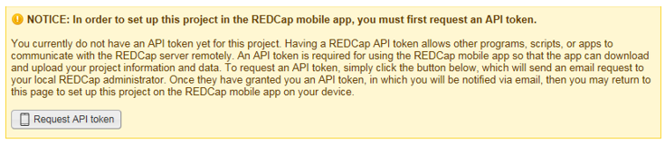
- Once the token is created by the REDCap admin team, the user is notified by email.
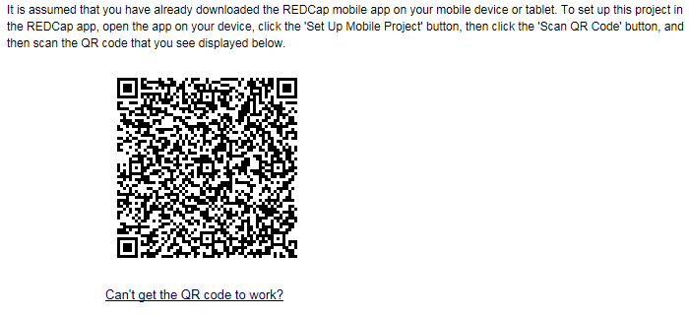
- A QR code is now available through the ‘REDCap Mobile App’ section for the user to set-up the project on the App.

Download the app
Download the REDCap Mobile App directly on your device by using below links or log in your App store and search for "redcap" (Vanderbilt University)
iOS app: https://itunes.apple.com/us/app/redcap-mobile-app/id972760478
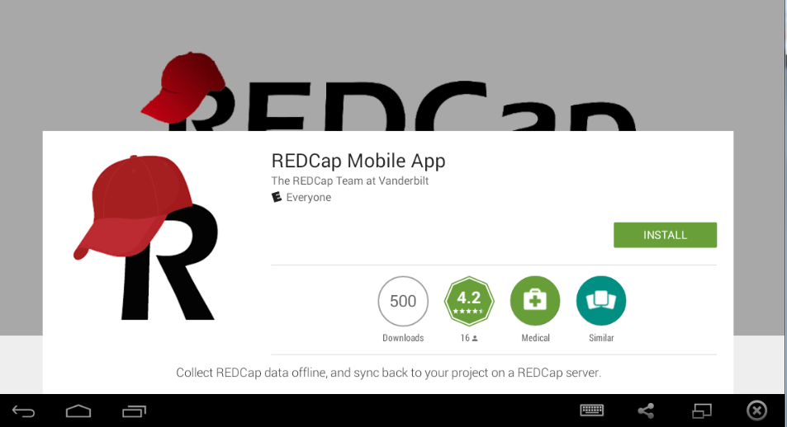

Android app: https://play.google.com/store/apps/details?id=edu.vanderbilt.redcap
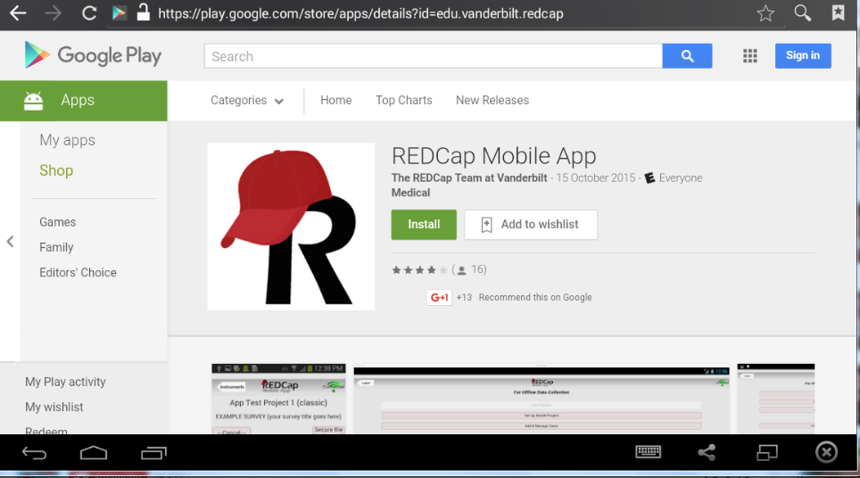

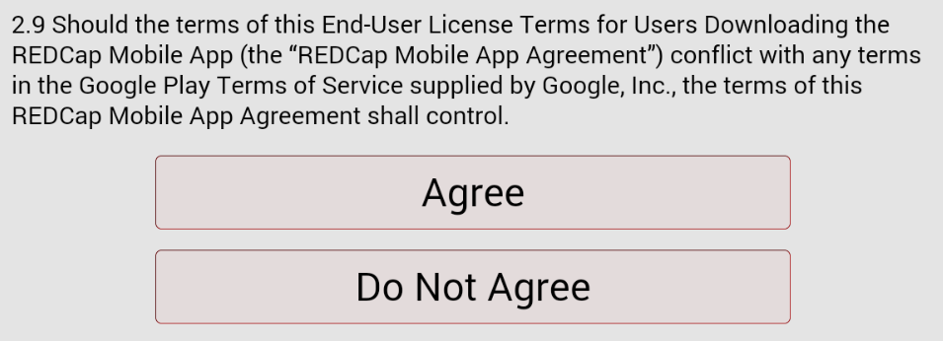
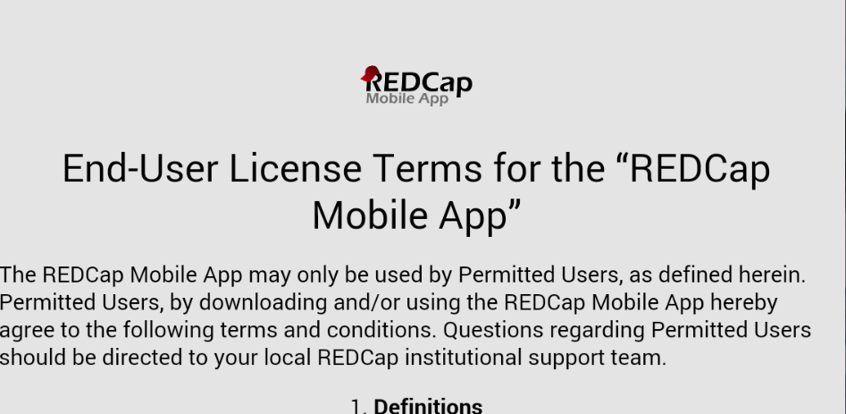
Note: To use QR code, your device must have a built in camera and a QR code reader App installed. An alternative way to set up this project in your REDCap App on your mobile device or tablet is to use an initialization code. The initialization code will expire in 10 minutes.

Using Mobile App
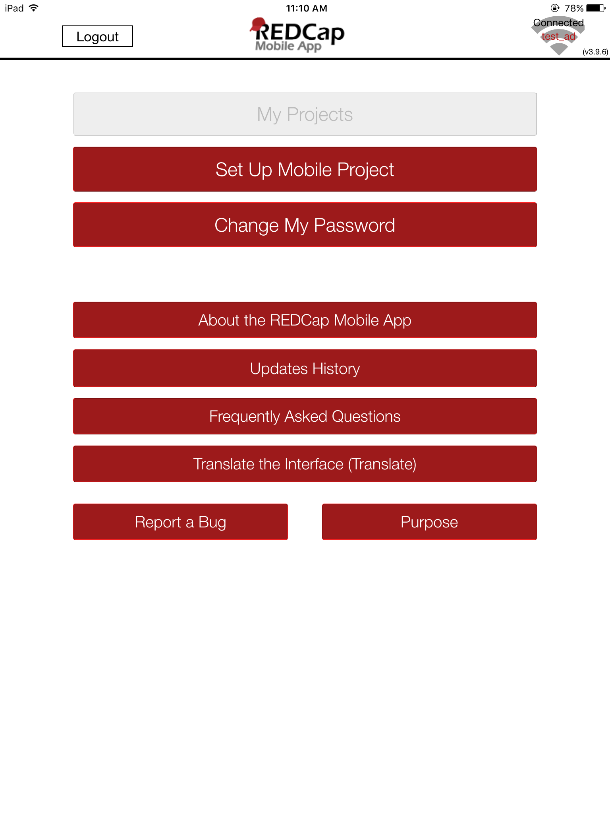

- Select: Set Up Mobile Project

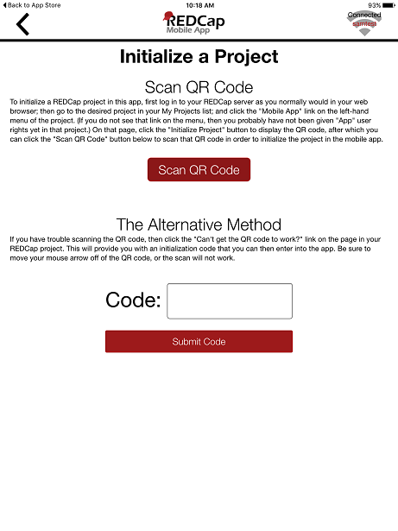

- Scan QR Code or Enter Initialization code (10 digit)
Note: To use QR code, your device must have a built in camera and a QR code reader App installed.

- Downloading the project. In addition to the data collection instruments, you can choose whether you want to download data from the project or not (when allowed).

Your project will now appear in the "My Projects" page. Data Entry personnel can now download the REDCap project to their Mobile App too (make sure they have requested a Mobile App API token as well):
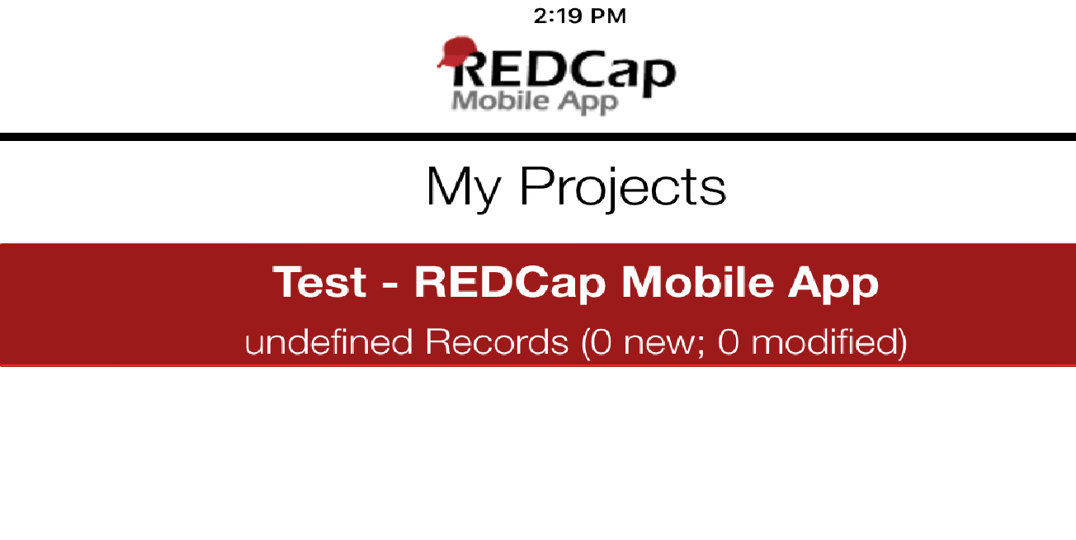
- If you have records in the project already, the app will prompt you whether you’d like to add these records (some or all) from the online version to your app version, or leave the project blank in the app (option 1 & 3 below):
- You can also download records to the app based on form status, or get a partial set of data. You can choose to only pull in certain records, or only certain events or arms, or a combination of both (option 2 below):
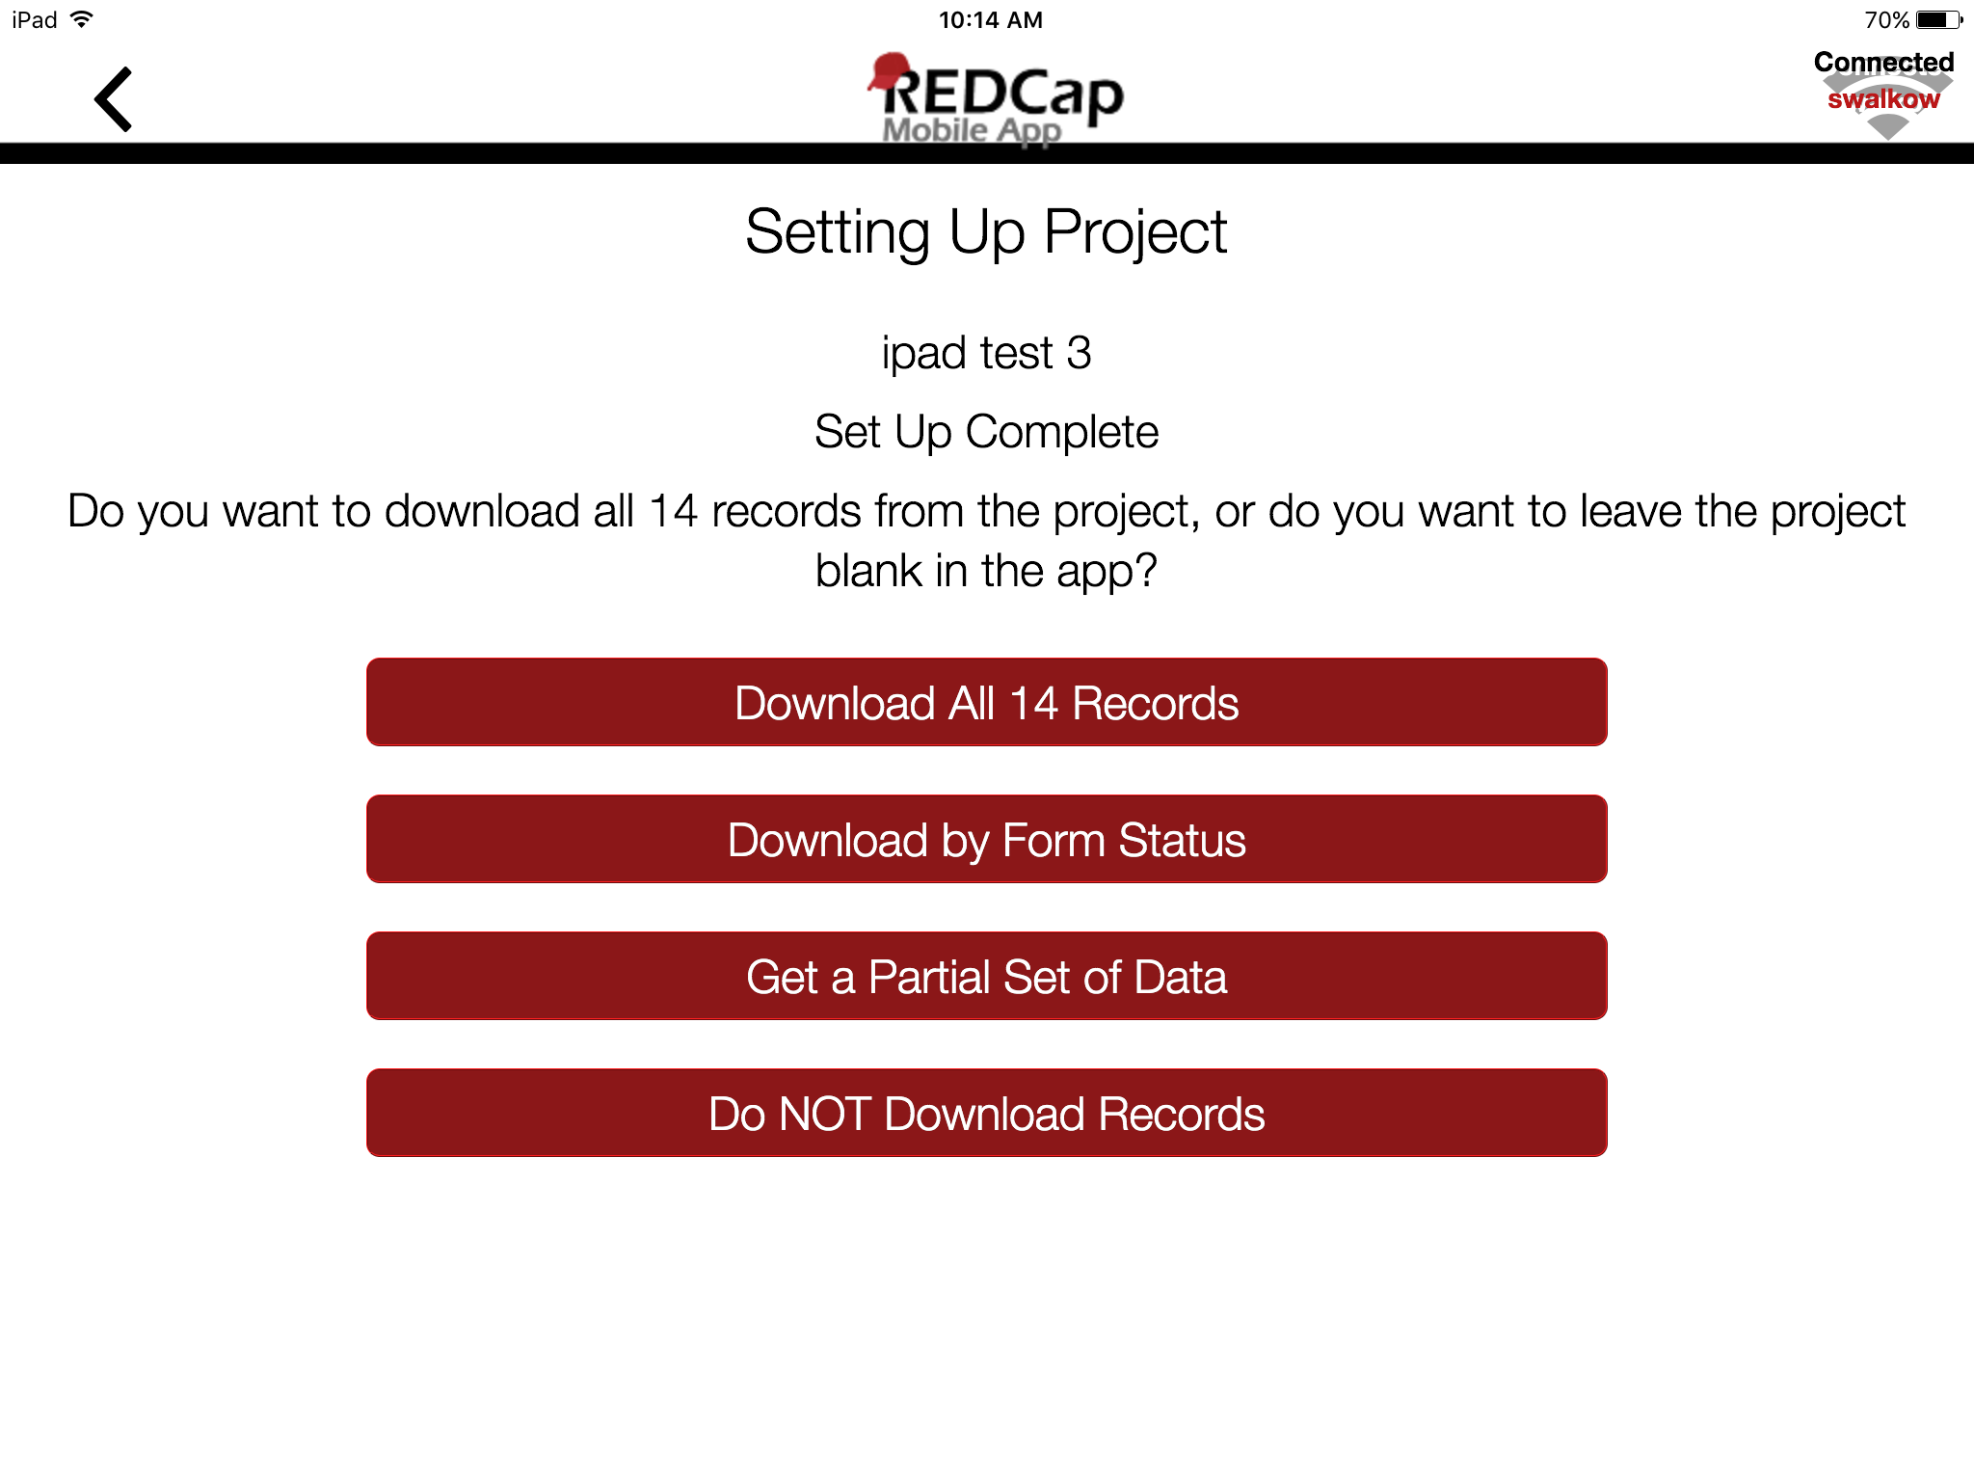

- Download partial set of data:
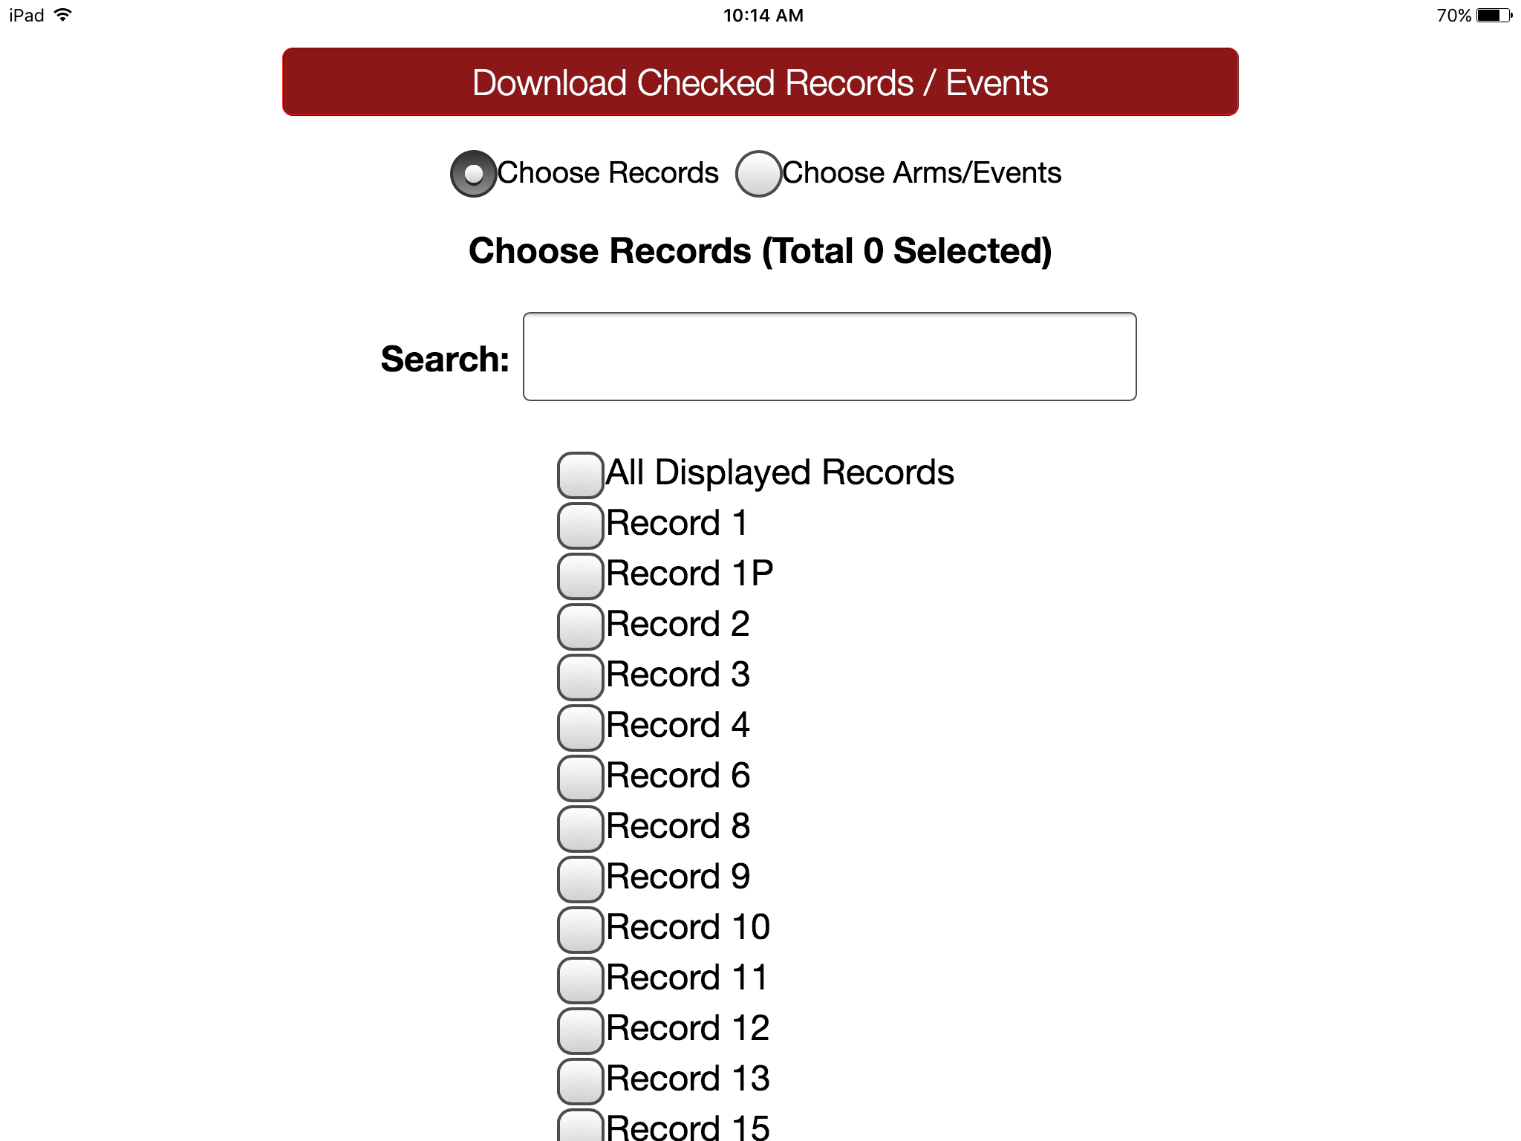

Data collection (OFFLINE – NO INTERNET CONNECTION)
- Tap the Collect Data button and choose an instrument and a record. Enter data and set the form status at the bottom as needed.
- Records can be renamed on the first form for projects with auto-numbering disabled. Note that renamed records will appear as new records when uploaded to the main database, so you will need to delete the original record there to complete the replacement process.
- Instruments can be secured so that participants/users will only have the option of entering data (and not traversing the rest of the app, which can jeopardize confidentiality). They can be unlocked via the primary user's pin.
- All data collection can be offline – without Internet access.

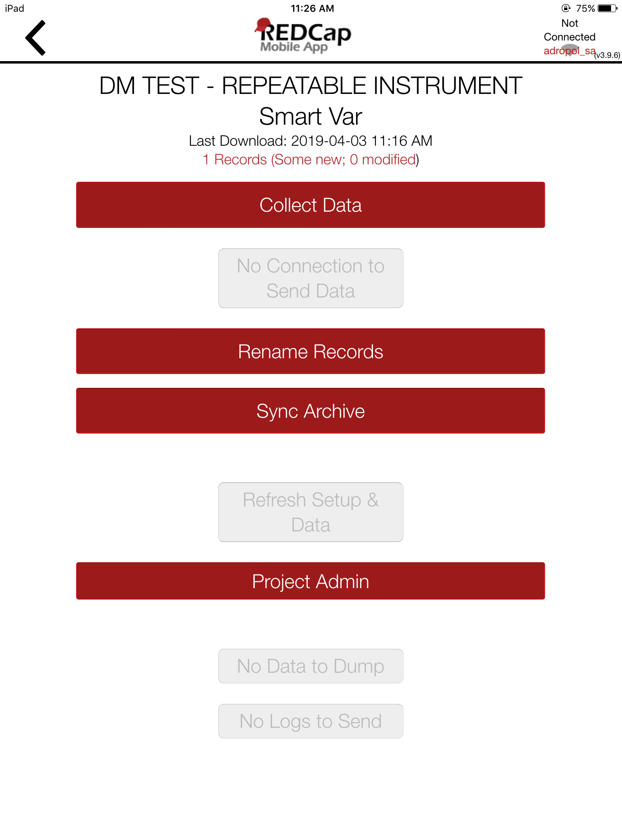

Sending Data
When mobile device is connected to internet, you can send data to the main REDCap project on the server/online.

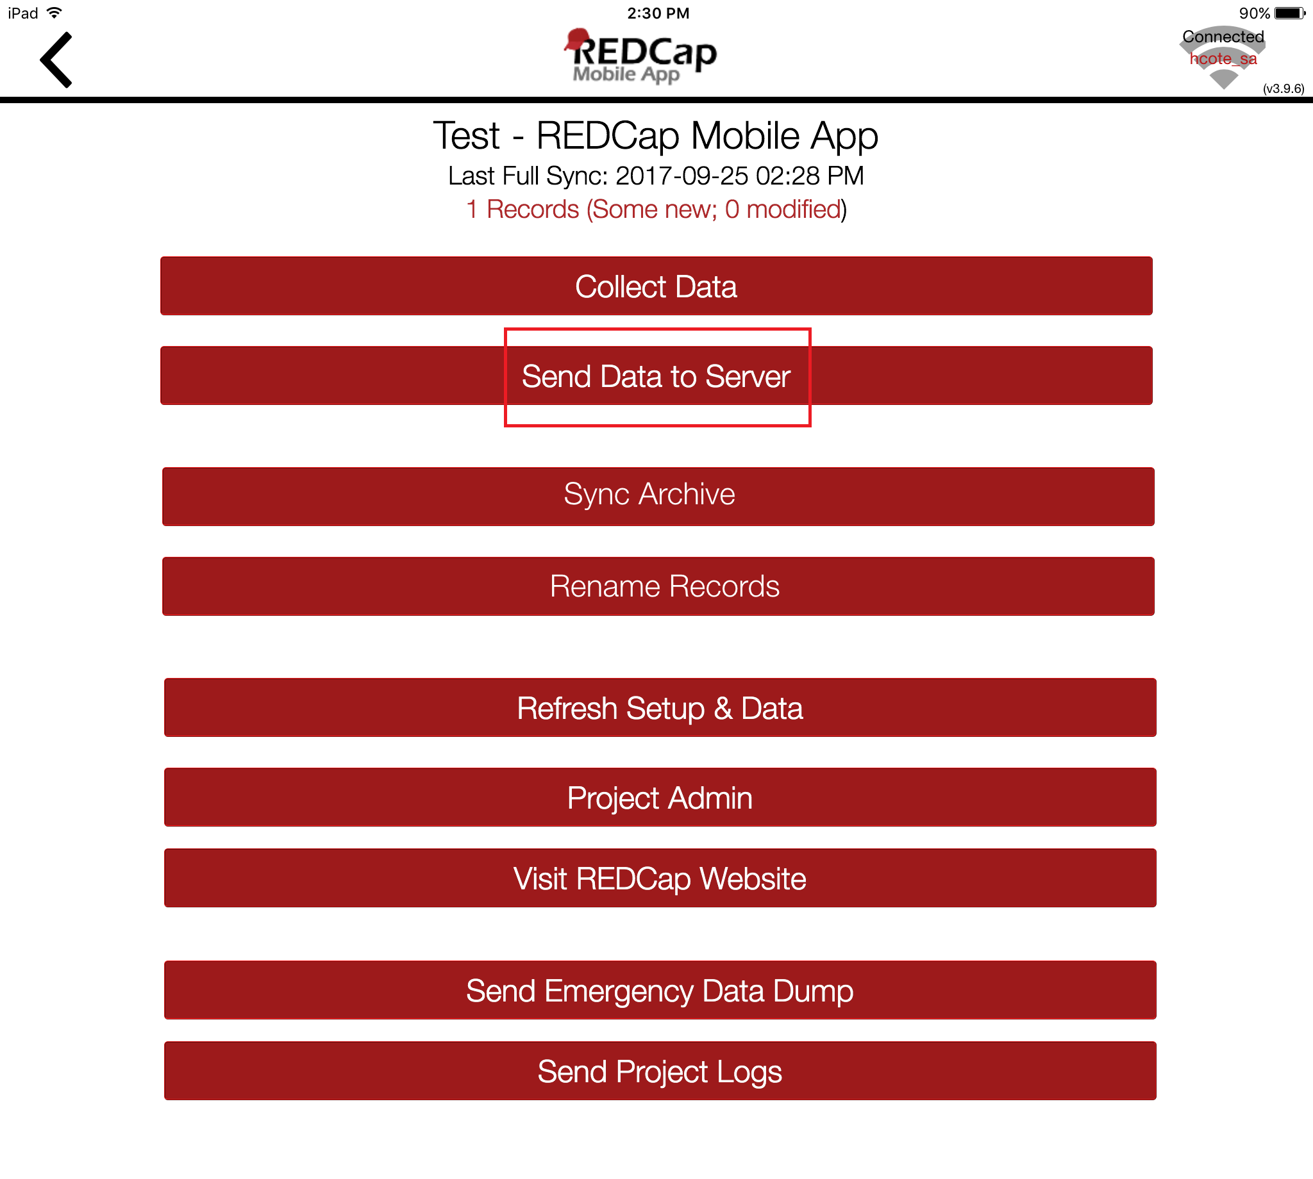
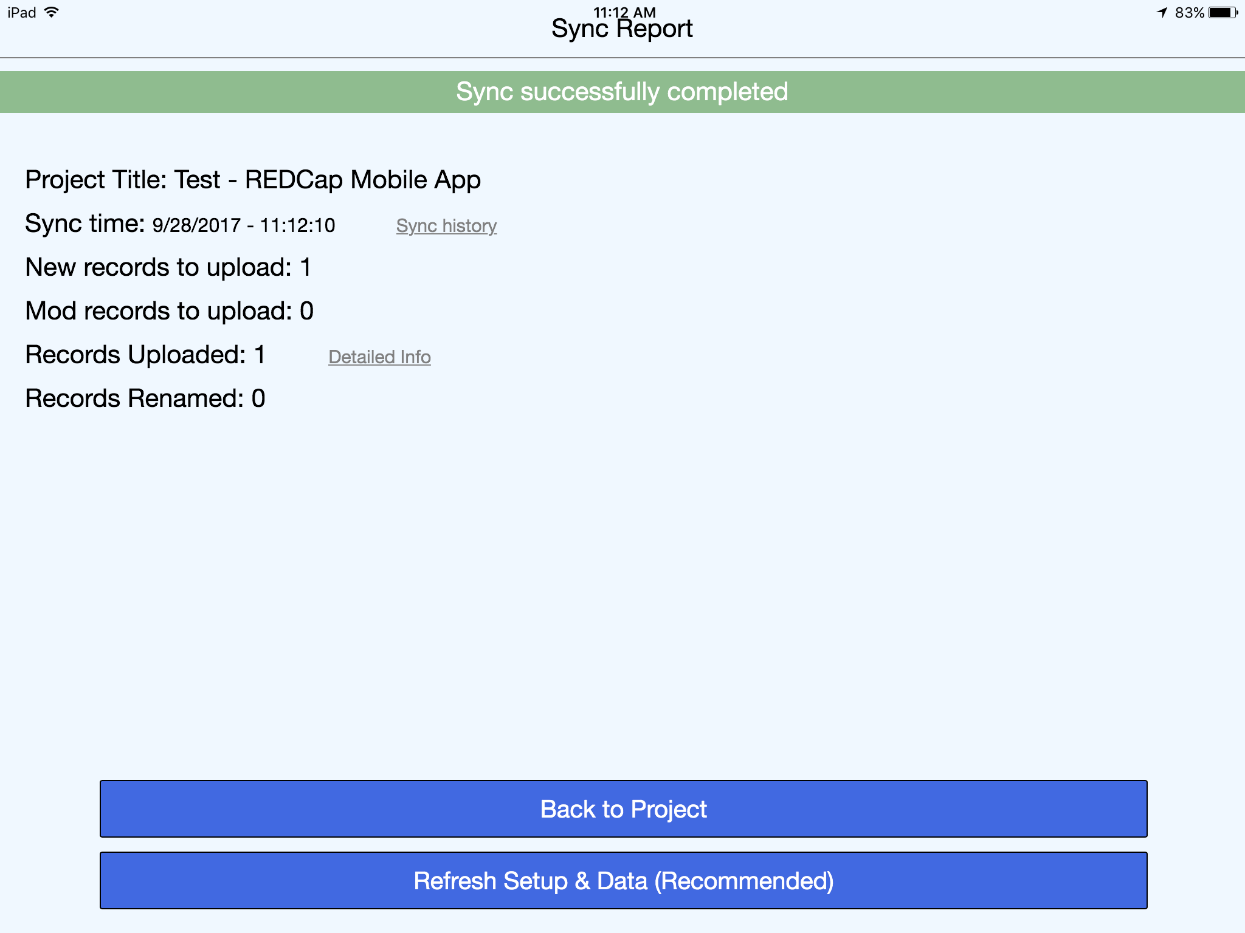

New Records
- Will be added to the main REDCap project immediately if no conflicts exist.

Existing Records
- For projects with auto-numbering disabled, an option to send the data to the server for each modified record appears, as well as the opportunity to view details of the differences between server data and app data for that record:
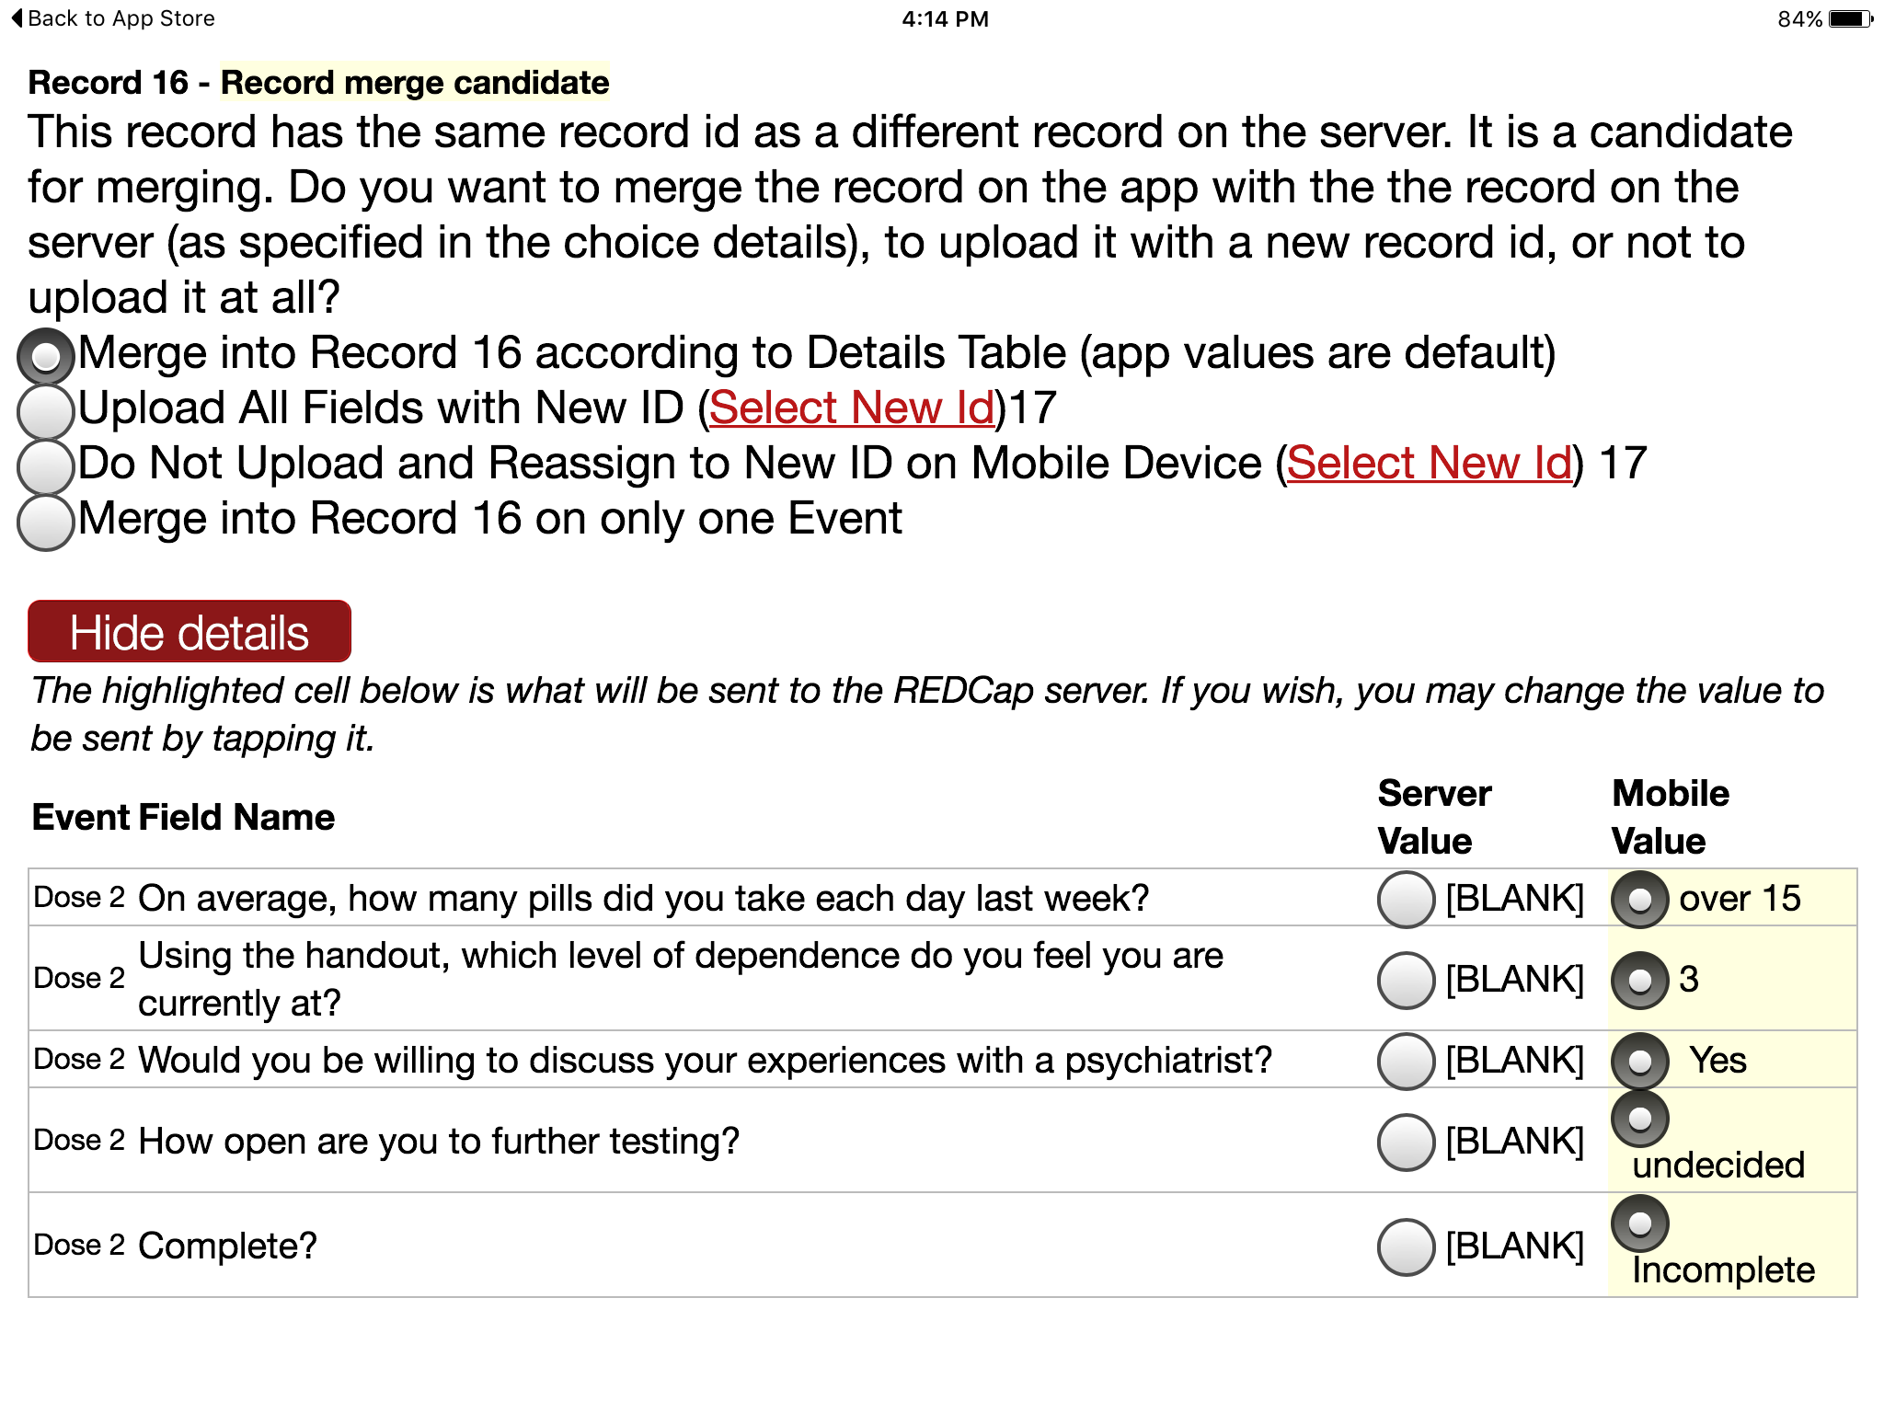

- If a record is deleted from the app, it will not be deleted from the server after data syncing. You may only delete records from the main project on the server.
- You can also send a partial set of records, which is recommended when you have a large number of records to send.

Three options after data is sent
It is recommended to click “Refresh Setup & Data” to remove all data stored on the mobile device and replace with the most current project information from the main REDCap project.

Send Emergency Data Dump
When something prevents the app from sending data back to the server normally, you can use “Send Emergency Data Dump” option to send data to the server as a CSV. The file will show up under Mobile App File Archive tab.
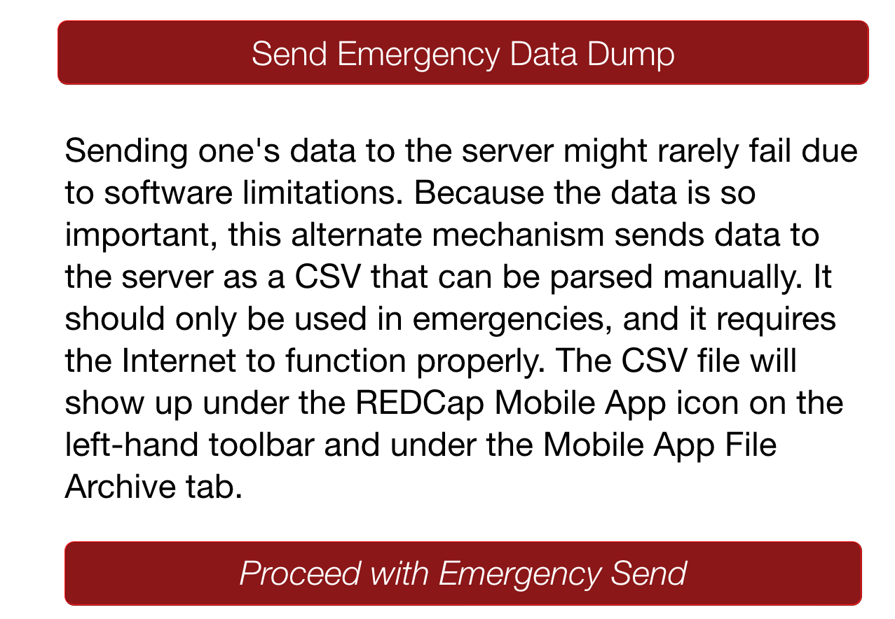
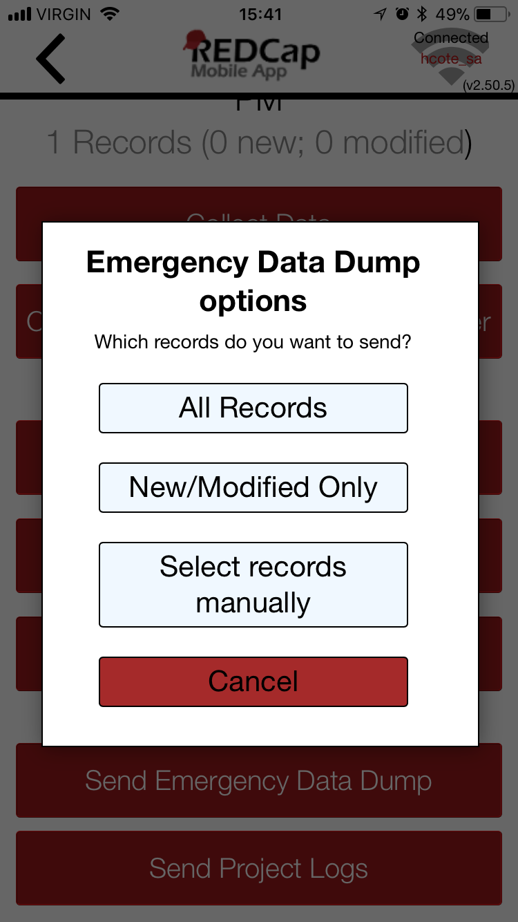

Remote Lockout
- Revoke “REDCap Mobile App” user privilege on the User Rights page in the project to prevent users from accessing the project on their mobile devices.
- Delete API token to perform remote lockout. In this way, the lockout will be permanent and will cause all data currently stored in the app to be lost.
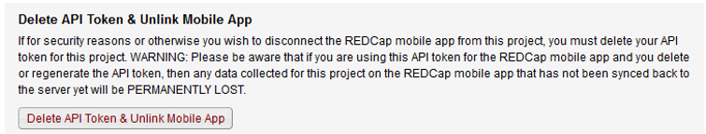

Mobile App Activity Log
- Project log for activity on the REDCap Mobile App is stored in the main project Mobile App File Archive. These can be transmitted to the server (for one given project) via the Send Project Logs button on the Project menu.
- It records data creation, modifications, and uploads; renaming, deletion, and viewing of records; and downloads of project instruments and records.
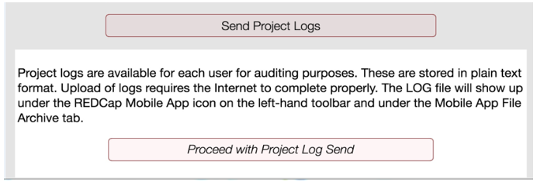

REDCap Mobile App in REDCap database, or online on a device (not in App)
The Mobile App page in a project contains methods for keeping track of project activity from many devices at a time
- Each device that has access to the project in the mobile app will be displayed in a device list
- The list will display the device’s UUID, but devices can be nicknamed (e.g., Kenya tablet, Rob’s iPhone)
- The nickname will display on the Mobile App page’s activity tables, dashboard, and file download tables so that users may track which device is doing what:
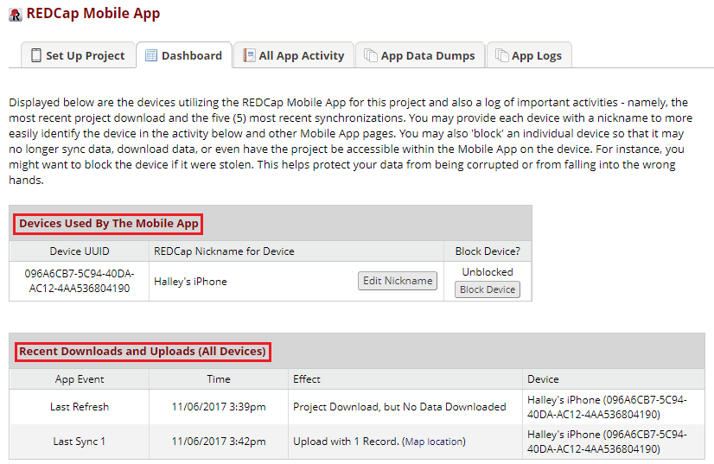

Each device can be blocked on a per-device basis if needed, without having to revoke the API token
- For example: to block a device if it were stolen; this helps protect your data from being corrupted or falling into the wrong hands:
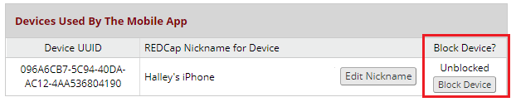

The mobile app log files can now be viewed on the Mobile App page without having to download them to view them:
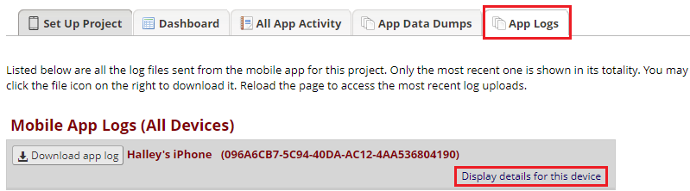

Reporting a bug/problem
Data collectors should use the reporting feature within the device itself to submit a troubleshooting request.
Study team leads can send an email to redcapapp@vumc.org with their question. Please be sure to provide this information:
- Type of device
- Device operating system version
- When the error occurred
- Any recent updates to project
- Does it occur for multiple users?

Translate the Mobile App Interface
You can translate the interface (buttons, instructions, etc.).
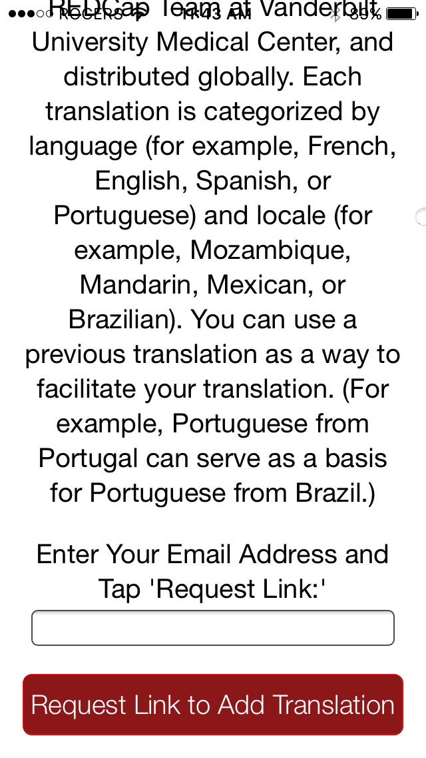
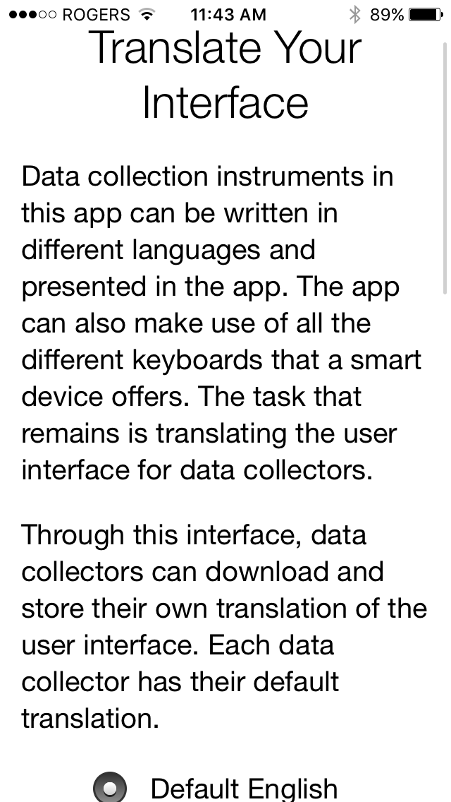
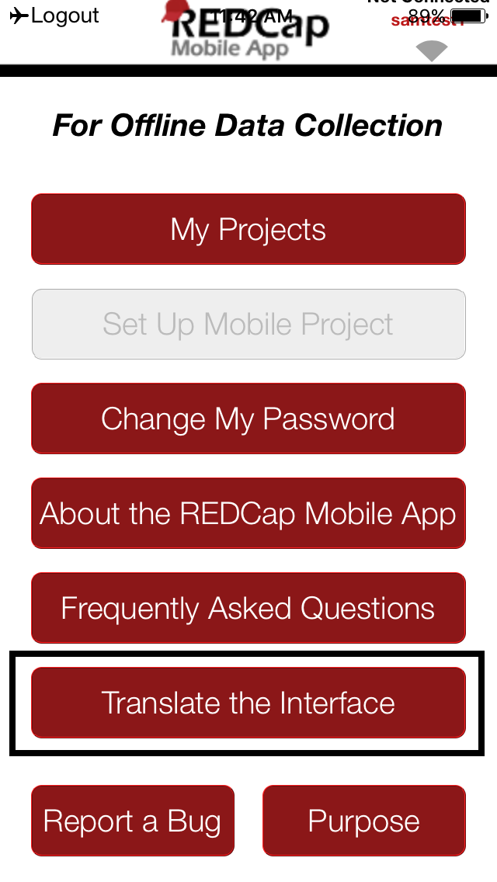

Current interface translations

- This will be applied to the entire app
- Translations are done by other REDCap users, and you can request a translation
- This feature does not translate your instruments, just the interface around them
- Current languages available for translating the REDCap interface:
  - Default English
  - Latam – IECS Spanish (Argentina)
  - Chinese (China)
  - Francais (France), Francais (Francophone)
  - IPFR French (Institut Pasteur)
  - Japanese (Japan)
  - Traditional Chinese (Taiwan)
  - German (Germany, DE)
  - Vietnamese (Vietnam)
  - Google Translator Portugese (Para os inquiridores)
  - Vietnamese (Vietnam)
  - Portugese – Brazil Portugese (Brazil)
  - DE German (LMU – UNIKA-T Augsburg)
  - Russian (Russia)
  - Vietnamese (SCDI) (Vietnam)
  - Tieng Viet Vietnamese (Vietnam)

Action Tags
Action Tags are special terms that begin with the '@' sign that can be placed inside a field's Field Annotation. Each action tag has a corresponding action that is performed for the field when displayed on data entry forms and survey pages. A few of these action tags are just for the mobile app, and they are listed below:

@HIDDEN-APP Hides the field only on the form ONLY on the REDCap Mobile App. Field will stay hidden even if branching logic attempts to make it visible.
@READONLY-APP Makes the field read-only (i.e., disabled) on the form ONLY on the REDCap Mobile App so that its value cannot be changed.
@BARCODE-APP Allows the REDCap Mobile App to capture the value of a barcode or QR code by scanning it with the device's camera. NOTE: For use only in the REDCap Mobile App.
@APPUSERNAME-APP In the REDCap Mobile App, it sets a field's value to the app username of the current mobile app user - i.e., their username in the mobile app, which is not necessarily the same as their REDCap server username that can be captured using @USERNAME. NOTE: For use only in the REDCap Mobile App.
@SYNC-APP Can be used only for File Upload and Signature fields. If the project is initialized in the REDCap Mobile App, this will cause any image files uploaded to a record to be sent to the app so that they are viewable in the app when editing the record. NOTE: For use only in the REDCap Mobile App

You can apply the actions while building your project on the server side, before downloading the
app to your device.

Best Practices
- Establish a point of contact for the project in general and for the person managing data collectors
  - If different people, the field manager should be as well trained as the person setting up the project
- For best audit trail logging, all users need their own API token
- Test the project on the app before rolling out
  - Formatting will look different
  - Look for significant changes in validated forms
- Develop a contingency plan if the app fails
- Take advantage of being able to label devices in the project
- With all researchers/data collectors:
  - Review device and app security
  - Instruct them if they need to lock forms when doing data entry
  - Review what features do/don’t work on the app
  - Consider providing one-on-one training or provide Powerpoint or Word instructions with screenshots
  - Teach them what to do when the app fails
- Be aware of any potential issues with changing the data dictionary when using the app
- Make sure to not have all devices under 1 API
- Set the user rights for each user so that they only have access to the data they need to have access to. If the project is a longitudinal project, you can download only the pertinent arms or events.
- To get a separate API token for 1 user, create different user accounts for that person.
- Write the protocol for using the Mobile App into your IRB application, if applicable.

In-Depth Manual in the App
Once a data collector downloads the app onto their device, there is an in-depth manual within the app. Click “About the REDCap Mobile App” to see a brief summary and the option for a more detailed manual.
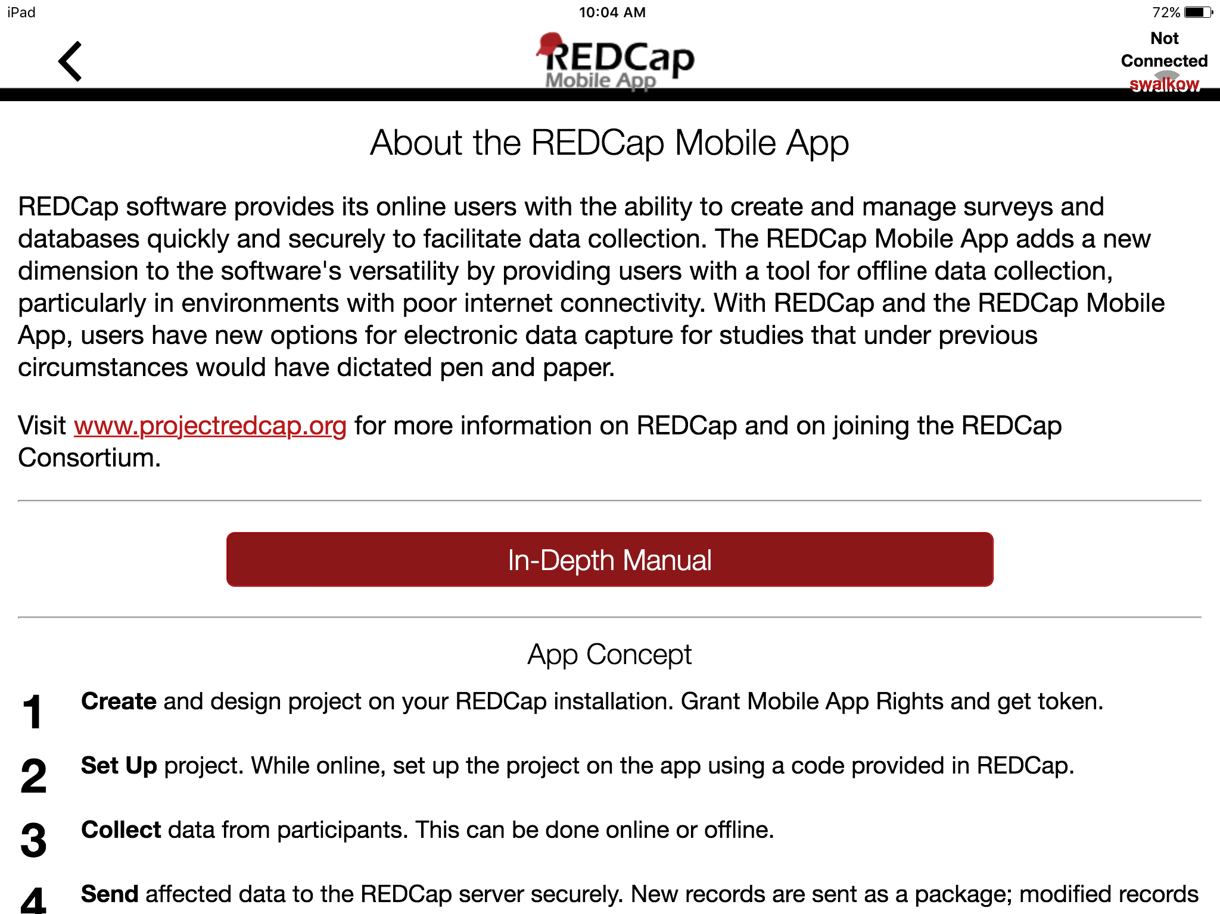
You can also view the in-depth manual here: https://projectredcap.org/wp-content/uploads/2019/07/In-Depth-Guide2019.pdf

Frequently Asked Questions
What features of REDCap are supported?
- Data entry
- DAGS
- GPS
- Pictures, videos, and audio can be uploaded into designated file fields.
- Signatures fields
- Action tags
- Instruments can be secured so that participants/users can enter their own data.
- Repeating instruments/events

What noteworthy features of REDCap aren’t supported?
- CATS (Computer Adaptive Test Surveys)
- Double data entry
- Survey specific features
- Survey queue
- Randomization
- Viewing files
- Inline audio/video
- Survey instructions
- Survey stop actions
- Survey thank you text
- Downloadable files in file fields
- Most External Modules are not supported

How are surveys and forms handled?
Normal REDCap Survey features are not used for Mobile App data collection. They are treated as entire forms without the pagination. Instruments can be secured with a pin so that participants/users will only have the option of entering data when the device is handed over to them. The instrument can be locked/unlocked via the primary user’s pin.

What are the weaknesses of the app?
If you have online access, use regular REDCap to collect data. It even works on the browser of your portable devices. You can also send data simultaneously from multiple devices.

What is the workflow of the app?
- Via an admin: Create a user; push projects to them; let them collect data; allow them to send data or send data yourself; clean & refresh the project; repeat; remove project.
- Via a user: Set up a project or multiple projects; collect data; send data; clean & refresh the project; repeat; remove project.

Can I limit users of my app so that they cannot do all functions?
User access can be restricted through the administrator interface. An administrator on the app can assign users the appropriate level of data access rights.

Can I use multi-tablet setups?
Yes, so far (September 2015) the record is 80 tablets.

Can I use data access groups?
Yes, Data Access Groups (DAGs) are supported by the app. Whichever REDCap user supplies the download code – this user’s DAG is used.

Can I restrict access to data?
Access to data can be restricted by using DAGs. You can also restrict all data via the user rights.

What happens if a tablet or phone is stolen?
Go to REDCap and revoke the API token – unless there is more than one device distributed with this token. If there is only one device, revoking the API token will not allow the thief to send data, download new data, or refresh the project. Further, when online, the thief cannot access any existing data. If there are multiple devices, revoking the API token will disable ALL devices. Use with care. Either way, access is protected with a PIN.

Instrument Design Hints
- You can include any fields and images (including signatures).
- You can’t include video or audio as those will not be downloaded.
- You can’t include external PDFs as those will not be downloaded.
- Signatures will be downloaded as those seem important enough information for a small amount of bytes.
- Regular file fields will not be downloaded. Their filenames and sizes will attempt to be downloaded.
- Don’t make your forms too long. Shorter (< 100 fields) fields seem to work better with users. 1000+ field forms can induce frustration. Making your form too long can crash your device. Break up a long form into smaller forms and use the “Save and Go to Next Instrument” button.
- Heavy amounts of branching logic and calculations will slow down the rendering of your form.

MyCap
MyCap captures patient-reported outcomes, similar to REDCap surveys. Data is entered by the patient via the app. For more information, see https://projectmycap.org/

REDCap vs. MyCap comparison
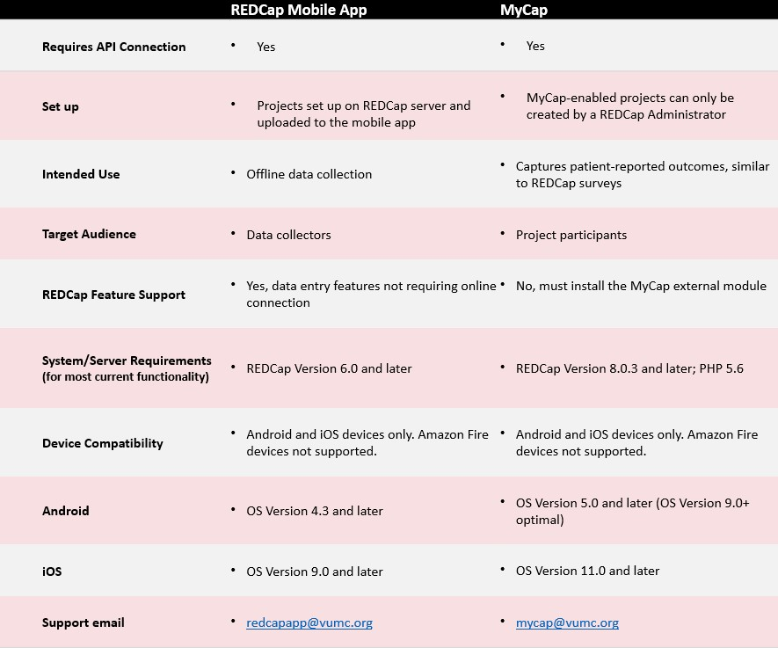

Resources
Weekly Mobile App Assistance Call, every Monday at 9AM central at https://global.gotomeeting.com/join/305129941
Email: redcapapp@vumc.org
Training Videos:
REDCap Mobile App Overview
REDCap Mobile App Project Setup
Installing the REDCap Mobile App

Acknowledgements
This manual was heavily adapted from the manual that the team at British Columbia Children’s Research Hospital created for their end users. As well, Vanderbilt colleagues Giovanni Delacqua and Michelle Fernandez provided invaluable input and content. We thank them for their contributions!

