Steps for Entering Administrative Leave on Employee Timesheets

- Log into the eUMB Portal
- Click on Timesheet Icon
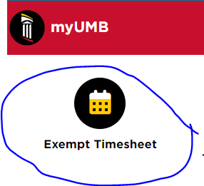

- Then add your timesheet or pull an existing timesheet up if you already starting filling it out and saved it:
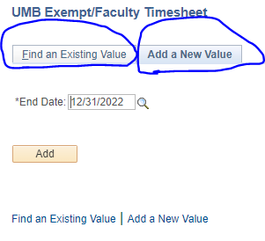

- Once the timesheet opens, click on the + at the end of one of the Paid Leave rows
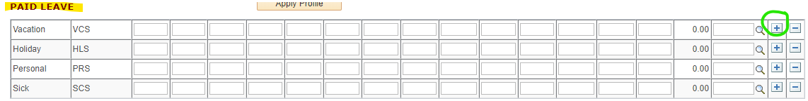

- Once the new row populates, click on the magnifying glass
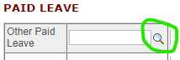

- Click on the appropriate leave code
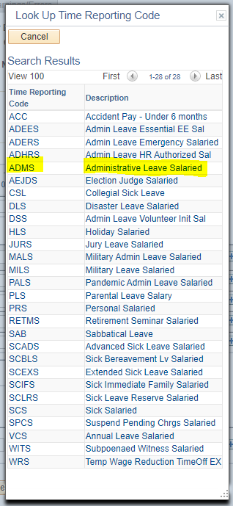

- Then enter the number of hours on the appropriate day

